How To Use POSTMAN To Send SMS By API



## Step 1:Please download the latest POSTMAN

<https://www.getpostman.com/downloads/>

## Step 2:Please disable these option

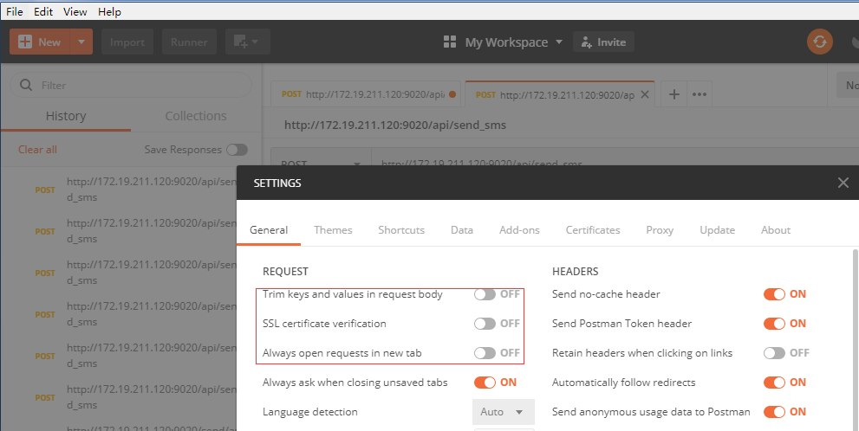

## Step 3: Type the URL

The supported format instance is *http://172.19.1.116/api/send_sms*

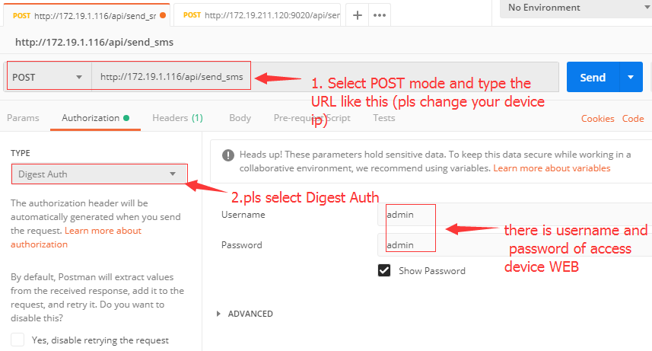

please notes:if your device web port is not default 80,you must type specific port in URL

for example



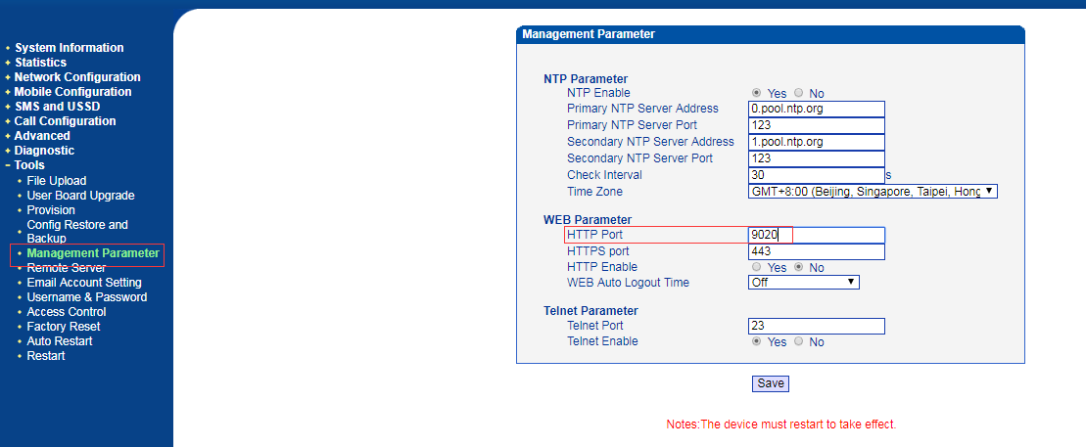

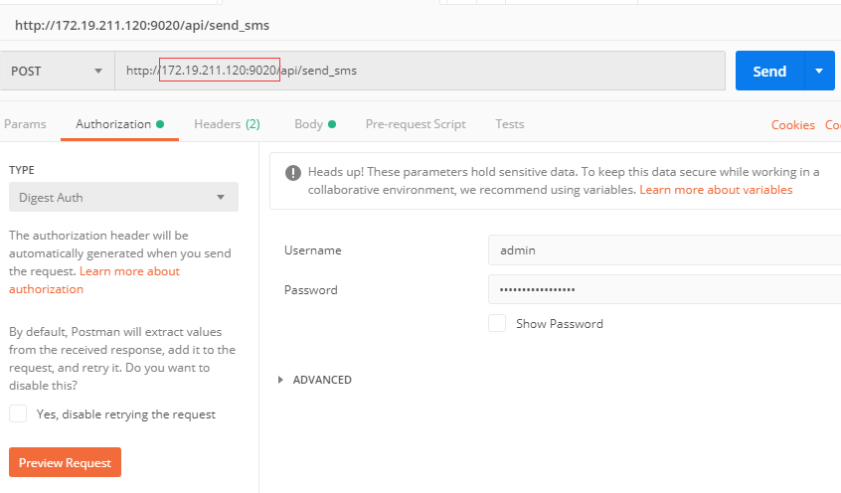

## Step 4:Type 'Content-Type' and 'application/json' in Headers

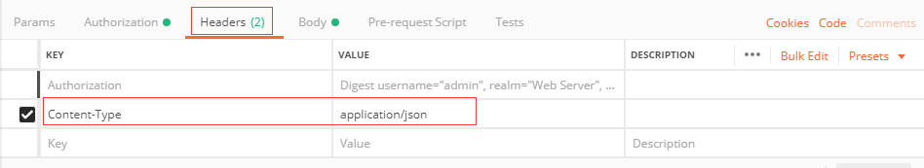

## Step 5: Fill in SMS content in Body and pls select 'JSON(application/json)

there is SMS demo:

{"text":"#param#","port":[0,0],"param":[{"number":"10086","text_param":["bj"],"user_id":1},{"number":"10086","text_param":["ye"],"user_id":2}]}

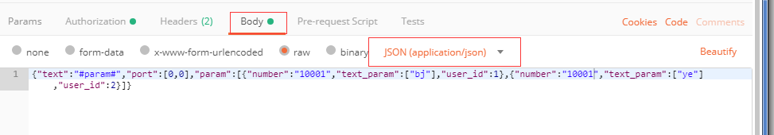

## Step 6: Click send and will get the response

